<https://www.figma.com/proto/wOUvR2e6lR48pxexI0bUCB/Cinema-(Community)?node-id=0-1&t=NUVR5xaUhcHQotXj-1>

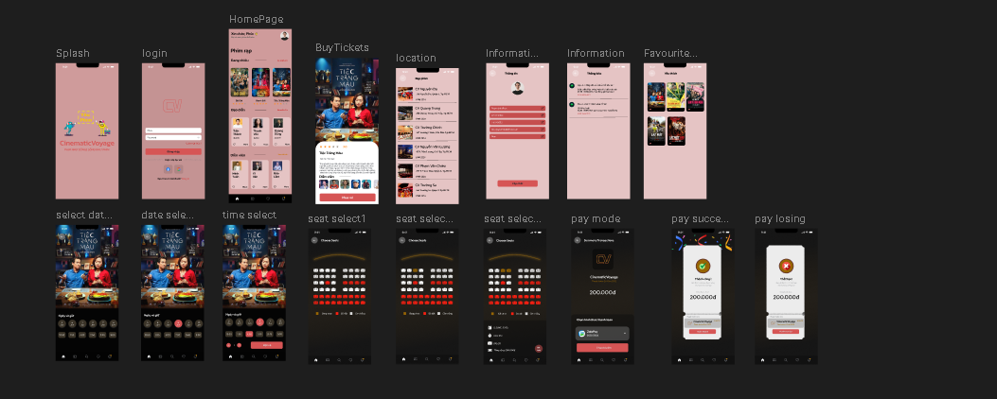

<https://www.figma.com/design/wOUvR2e6lR48pxexI0bUCB/Cinema-(Community)?node-id=0-1&m=dev&t=TlbKxGYCn63cwvzC-1>

<iframe style="border: 1px solid rgba(0, 0, 0, 0.1);" width="800" height="450" src="https://embed.figma.com/design/wOUvR2e6lR48pxexI0bUCB/Cinema-(Community)?node-id=0-1&embed-host=share" allowfullscreen></iframe>